PCHSecm.weebly.com ECM Unit 1 Statistics Calendar

Name: ____________________________
27 |  | 28 |  | 29 |  | 30 |  | 31
Introduction Activities  Pre-Test  HW: Syllabus signed, log on to Canvas, remind and pchsecm.weebly.com  Watch video on sampling |  | Continued practice of sampling techniques |  | Sampling & Variables PowerPoint  CW: Jigsaw & Assign Project  HW:  Worksheet on Sampling  Syllabus signed, log on to Canvas, log on to remind  Watch video on sampling |  | Quiz on sampling, data variables  Start --Statistical Graphs  HW: Select Group for Project and decide topic & finish classwork |  | Project Questions –  Groups and Topic selections are due  Statistical Graphs  Collect: Data for Quiz in class  HW: Finish classwork and collect data for project
3 |  | 4 |  | 5 |  | 6 |  | 7
 |  | Group Quiz on Graphs  HW: Project |  | Empirical Rule  HW: Worksheet |  | Empirical Rule  Project  HW: Worksheet on Empirical Rule, Study for Quiz and Project |  | Finish Projects  Quiz on Empirical Rule
10 |  | 11 |  | 12 |  | 13 |  | 9
Project Presentations-  TEST GRADE |  | 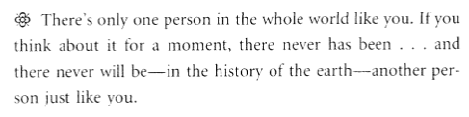  Fred Rogers  Embrace you uniqueness; Celebrate others uniqueness

